**Full Stack Development with MERN**

**Project Documentation**

**Introduction:**

A Grocery Shopping Mart can be built using the MERN stack (MongoDB, Express.js, React, Node.js) to create a fast, scalable, and dynamic e-commerce platform. The MERN stack offers a seamless full-stack development experience by leveraging JavaScript on both the client and server sides.

**Grocery Mart**

**Team leader:**

Sakthi K

**Team Members:**

Gopinath N

Kesavan R

Lakshmipathy V

**Project description:**

our basic grocery-web app! Our app is designed to provide a seamless online shopping experience for customers, making it convenient for them to explore and purchase a wide range of products. Whether you are a tech enthusiast, a fashionista, or a homemaker looking for everyday essentials, our app has something for everyone.

With user-friendly navigation and intuitive design, our grocery-webapp app allows customers to browse through various categories, view product details, add items to their cart, and securely complete the checkout process. We prioritize user satisfaction and aim to provide a smooth and hassle-free shopping experience.

For sellers and administrators, our app offers robust backend functionalities. Sellers can easily manage their product listings, inventory, and orders, while administrators can efficiently handle customer inquiries, process payments, and monitor overall app performance.

With a focus on security and privacy, our grocery-webapp app ensures that customer data is protected, transactions are secure, and personal information remains confidential. We strive to build trust with our customers and provide a safe platform for online shopping.

We are excited to have you on board and look forward to providing you with a delightful shopping experience. Happy shopping with our grocery-webapp!

**Goals:**

* Implement an efficient database structure for managing products and orders.
* Ensure secure and reliable data transactions between client and server.
* Design a modular and maintainable codebase.

**Objective:**

To create an online platform that replicates a real-world grocery shopping experience with the convenience of online purchase options.

**Core Features:**

1. **Product Browsing:** Users can browse a wide variety of grocery products.

2. **Cart Management:** Products can be added to a cart, with quantities adjustable before checkout.

3. **Order Management:** The system keeps a record of user orders, including order details and statuses.

4. **Admin Control:** Administrators can add, edit, or delete products, manage inventory, and handle order tracking.

5. **User-Friendly Interface:** A responsive, mobile-friendly interface for optimal user experience.

**Technical Architecture:**

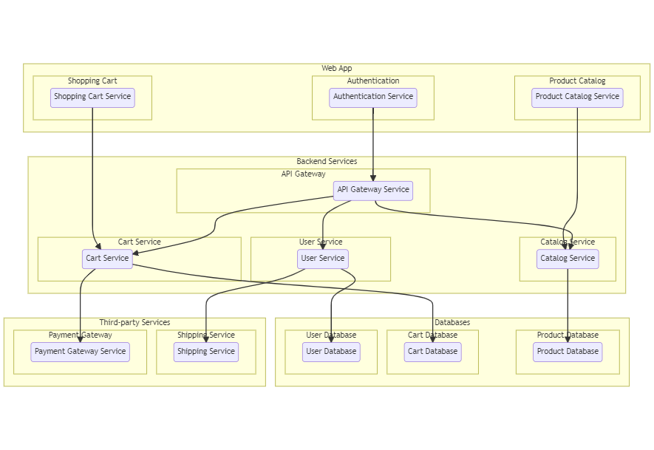

The technical architecture of an flower and gift delivery app typically involves a client-server model, where the frontend represents the client and the backend serves as the server. The frontend is responsible for user interface, interaction, and presentation, while the backend handles data storage, business logic, and integration with external services like payment gateways and databases. Communication between the frontend and backend is typically facilitated through APIs, enabling seamless data exchange and functionality.

**ER Diagram:**

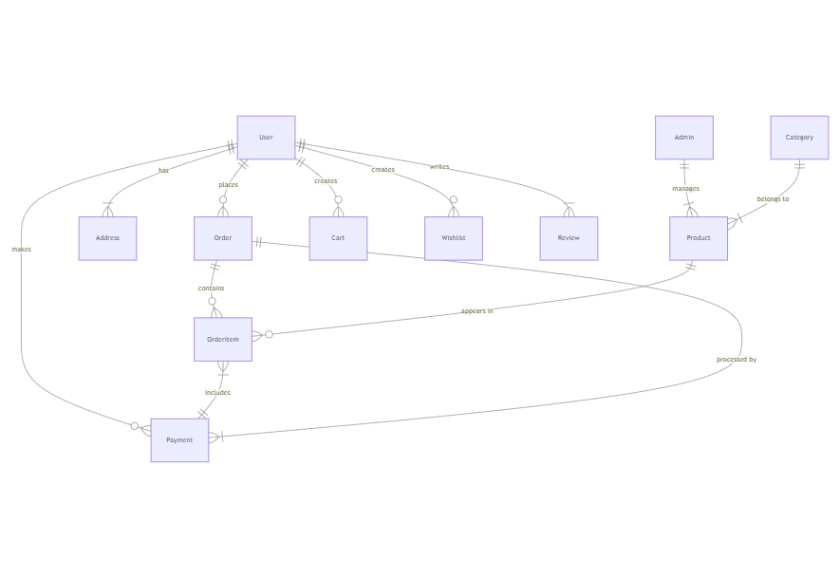

The Entity-Relationship (ER) diagram for an flower and gift delivery app visually represents the relationships between different entities involved in the system, such as users, products, orders, and reviews. It illustrates how these entities are related to each other and helps in understanding the overall database structure and data flow within the application.

**Project Structure:**

This structure assumes an Angular app and follows a modular approach. Here's a brief explanation of the main directories and files:

* src/app/components: Contains components related to the customer app, such as register, login, home, products, my-cart, my-orders, placeorder, history, feedback, product-details, and more.
* src/app/modules: Contains modules for different sections of the app. In this case, the admin module is included with its own set of components like add-category, add-product, dashboard, feedback, home, orders, payment, update-product, users, and more.
* src/app/app-routing.module.ts: Defines the routing configuration for the app, specifying which components should be loaded for each route.
* src/app/app.component.ts, src/app/app.component.html, `src.

**Role Based Access:**

Roles of Admin and User can be defined for an online grocery web application

**Project Flow:**

* Frontend Development
* Backend Development
* Integration

**Frontend Development:**

Frontend development involves building the user interface (UI) and implementing the visual elements of the online shopping web application. It focuses on creating an intuitive and engaging user experience that allows users to interact with the application seamlessly.

**User Interface (UI) Design:**

* Create a visually appealing and consistent design using modern design principles.
* Use a UI design tool like Adobe XD, Sketch, Figma, or InVision to create wireframes and mockups.
* Pay attention to typography, color schemes, spacing, and visual hierarchy.
* Use responsive design techniques to ensure the app looks great on different devices.

**Responsive Design:**

* Utilize CSS media queries and responsive design frameworks like Bootstrap or Tailwind CSS to create a responsive layout.
* Test your app on various devices and screen sizes to ensure a seamless user experience.

**Product Catalog:**

* Design and implement a product listing page that displays product images, titles, descriptions, prices, and other relevant details.
* Implement search functionality to allow users to find products easily.
* Include filters and sorting options to enhance the browsing experience.

**Shopping Cart and Checkout Process:**

* Design and develop a shopping cart component to allow users to add products, view cart contents, update quantities, and remove items.
* Create a checkout process with multiple steps, including shipping information, payment selection, and order review.

**User Authentication and Account Management:**

* Design and implement a user registration and login system.
* Create user profile pages where users can view and edit their personal information, addresses, payment methods, and order history.
* Implement authentication guards to restrict access to certain pages or features.

**Payment Integration:**

* Integrate with a payment gateway service like Stripe, PayPal, or Braintree.
* Implement a secure and seamless payment flow that allows users to enter payment details and complete transactions.
* Handle transaction success and failure scenarios and provide appropriate feedback to the user.

**Backend Development:**

Backend development involves building the server-side components and logic of the online shopping web application. It focuses on handling the business logic, processing requests from the front end, and interacting with the database.

**Integration:**

Integration is the process of combining and connecting the frontend and backend components of the online flower shop web application to create a unified and fully functional system. It involves establishing communication channels, exchanging data, and ensuring seamless interaction between the frontend UI and backend APIs.

**Frontend-Backend Integration:**

* Integrate the frontend UI components with the backend APIs, ensuring proper communication and data exchange.
* Implement API calls from the front end to retrieve the data.
* Handle data validation and error responses between the frontend and backend components.
* Conduct thorough testing to ensure seamless integration and compatibility between frontend and backend.

**User Interface:**

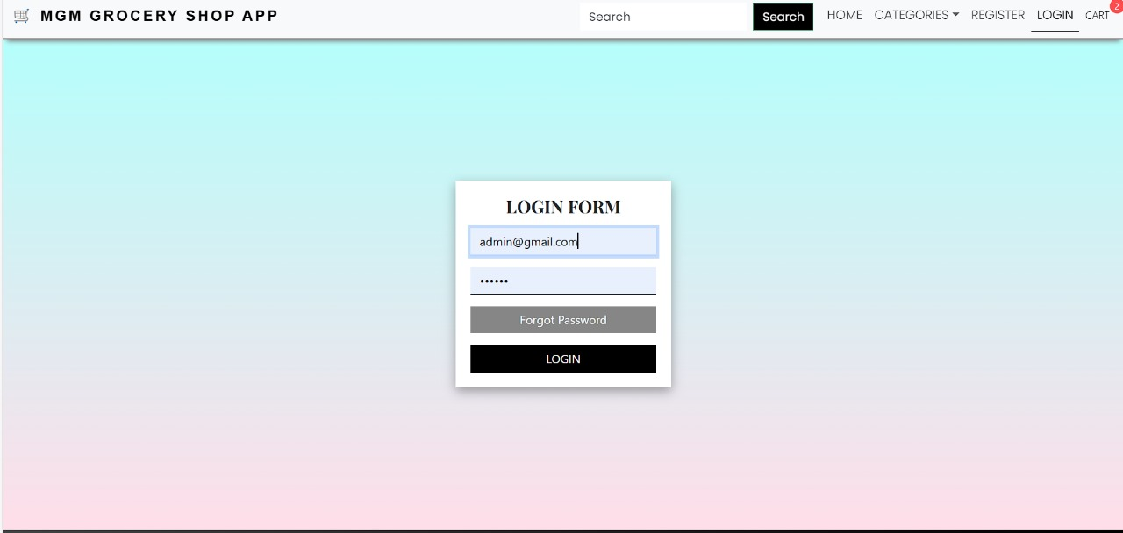

**Screenshots and Demo:**

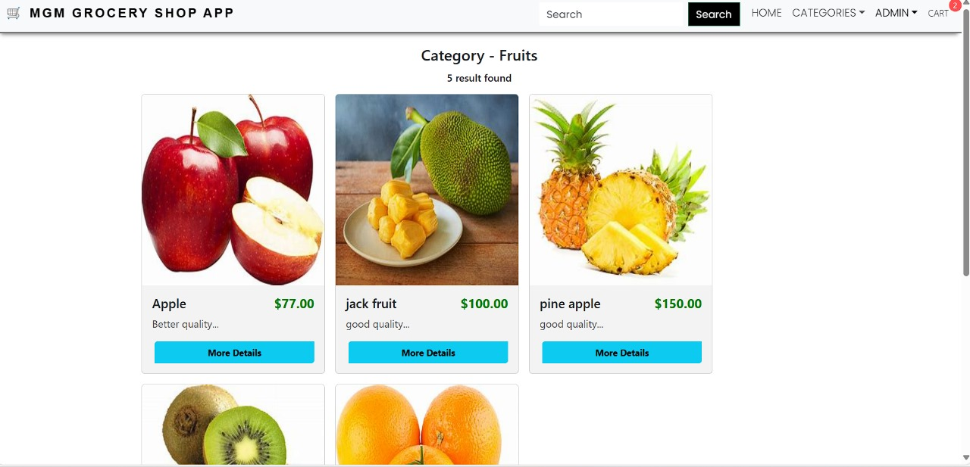

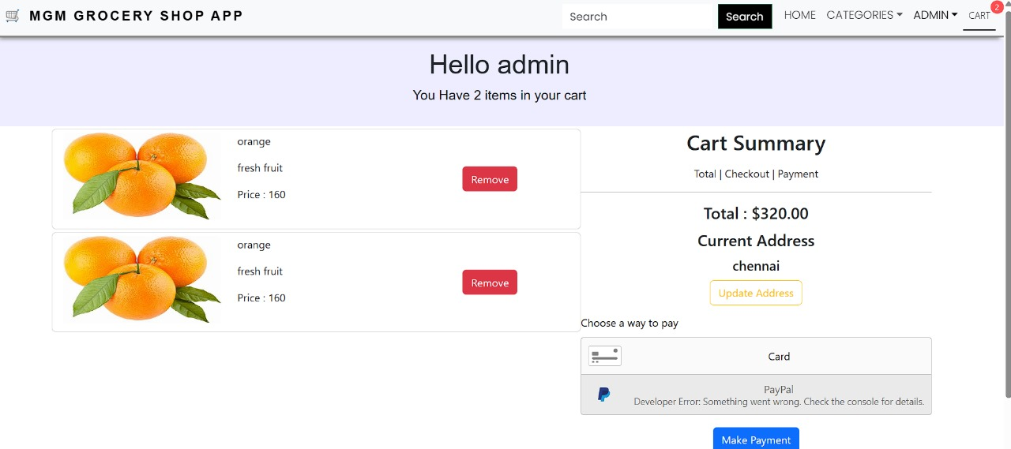

**GitHub link:**

<https://github.com/gokulachandran/MGM-grocery-shop/tree/master/ecommerce-app-2023-15-admin-orders-css>

**Known Issues:**

**1. Slow Loading Times**

* **Issue:** Slow page load times, especially when loading product catalogs, large inventories, or during search operations.
* **Cause:** Large amounts of data being fetched from the database without optimization, inefficient API calls, or unoptimized front-end resources (images, scripts, etc.).
* **Solution:** Implement pagination, lazy loading, and caching mechanisms. Consider optimizing API calls, using CDNs, and optimizing assets (images, JavaScript).

**2. Search and Filtering Limitations**

* **Issue:** Search and filter functionality may not be efficient or accurate. For example, products may not be sorted by relevance or price, and filters could be buggy.
* **Cause:** Lack of proper indexing or inefficient querying in the database, or poor front-end filtering logic.
* **Solution:** Use full-text search capabilities (e.g., Elasticsearch, MongoDB text search) and ensure the back-end API is optimized to handle complex queries.

**Future Enhancements:**

**1. Personalized Recommendations**

* **Enhancement:** Implement machine learning or AI-driven product recommendation engines to suggest products based on user behavior, preferences, and past purchases.
* **Benefit:** Increased customer satisfaction and potential sales by providing personalized shopping experiences.

**2. Voice-Activated Shopping**

* **Enhancement:** Add voice search and voice command features for hands-free shopping.
* **Benefit:** Improved accessibility, particularly for elderly or disabled users. Enhances user experience with cutting-edge technology.

**3. AI-powered Inventory Management**

* **Enhancement:** Use AI and predictive analytics to forecast demand and optimize stock levels in real-time. Integrate smart supply chain management systems.
* **Benefit:** Reduces overstock and understock issues, saving costs and improving customer satisfaction.